Name:Prajwal P Shindhe

**INTRODUCTION TO GSM**

1.ABSTRACT:The Global System for Mobile Communications (GSM) is a standard 2G networks developed as a replacement for first generation (1G) analog cellular networks. The GSM standard originally described a digital, circuit-switched network optimized for full duplex voice telephony. [Code division multiple access](https://en.wikipedia.org/wiki/Code_division_multiple_access) (CDMA) technology nor the 4G LTE [orthogonal frequency-division multiple access](https://en.wikipedia.org/wiki/Orthogonal_frequency-division_multiple_access) (OFDMA) technology.GSM is a mobile communication modem it is stands for global system for mobile communication (GSM). The idea of GSM was developed at Bell Laboratories in 1970.  It is widely used mobile communication system in the world. GSM is an open and digital cellular technology used for transmitting mobile voice and data services operates at the 850MHz, 900MHz, 1800MHz and 1900MHz frequency bands.

2.TECHNICAL DETAILS:

[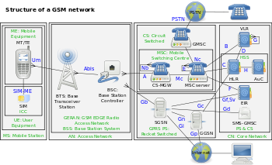](https://en.wikipedia.org/wiki/File:Gsm_structures.svg)

**The structure of a GSM network**

3.GSM MC60BOARD:

[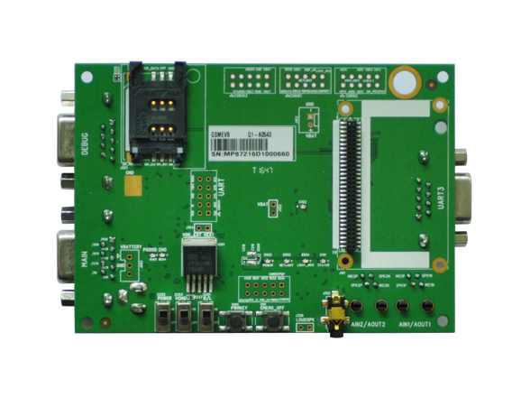](https://www.quectel.com/product/gsmevb.htm)

**4.BOARD DESCRIPTION**:MC60 is a quad-band full-featured GSM/GPRS module using LCC castellation package. With an extensive set of Internet protocols (TCP, UDP, PPP, FTP, HTTP and SSL), it has integrated the GNSS technology for satellite navigation. Based on the latest 2G chipset, it has the optimal performance in SMS & data transmission as well as audio service even in harsh environments. It features Dual SIM Single Standby function.

MC60 module integrates both GPRS and GNSS engines in one compact and low profile SMT package. It supports EPOtechnology

**5.Key Benefits:**

● Ultra compact size: 18.7 × 16.0 × 2.1mm  
● Multi navigation constellation: GPS/ GLONASS/ QZSS  
● GNSS receiver channels: 99 acquisition/ 33 tracking channels  
● Powerful AGPS functions: Autonomous AGPS EASYTM / Offline AGPS EPOTM / Online AGPS QuecFastFix  
● Built-in LNA for better GNSS sensitivity (-167dBm@Tracking): able to use passive GNSS antenna without the need of any extra LNA  
● Enhanced GNSS features: SDK command/ AIC/ LOCUS/ GLP  
● GSM quad-band: 850/ 900/ 1800/ 1900MHz  
● Multi internet protocols: TCP/ UDP/ PPP/ HTTP/ FTP/ SSL  
● Support Voice, SMS, QuecFOTA , DSSS, OpenCPU  
● Support Bluetooth V3.0: SPP & HFP-AG profiles

**6.WORKING OF A GSM NETWORK:**

A GSM modem is a device which can be either a mobile phone or a modem device which can be used to make a computer or any other processor communicate over a network. A GSM modem requires a SIM card to be operated and operates over a network range subscribed by the network operator.  It can be connected to a computer through serial, USB or Bluetooth connection.The security strategies standardized for the GSM system make it the most secure telecommunications standard currently accessible. Although the confidentiality of a call and secrecy of the GSM subscriber is just ensured on the radio channel, this is a major step in achieving end-to- end security.

7.GSM ARCHITECTURE:

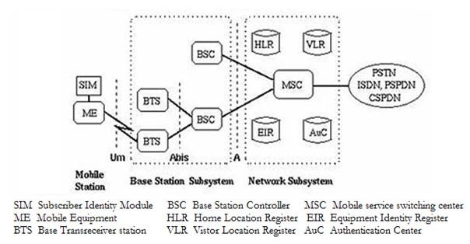

A GSM network consists of the following components:

The GSM network architecture consists of three major subsystems:

Mobile Station (MS)

Base Station Subsystem (BSS)

Network and Switching Subsystem (NSS)

The wireless link interface between the MS and the Base Transceiver Station (BTS), which is a part of BSS. Many BTSs are controlled by a Base Station Controller (BSC). BSC is connected to the Mobile Switching Center (MSC), which is a part of NSS. Figure shows the key functional elements in the GSM network architecture.

**1.A Mobile Station:**  It is the mobile phone which consists of the transceiver, the display and the processor and is controlled by a SIM card operating over the network.

**2.Base Station Subsystem:** It acts as an interface between the mobile station and the network subsystem. It consists of the Base Transceiver Station whichcontains the radio transceivers and handles the protocols for communication with mobiles. It also consists of the Base Station Controller which controls the Base Transceiver station and acts as a interface between the mobile station and mobile switching centre.

**3.Network Subsystem:** It provides the basic network connection to the mobile stations. The basic part of the Network Subsystem is the Mobile Service Switching Centre which provides access to different networks like ISDN, PSTN etc. It also consists of the Home Location Register and the Visitor Location Register which provides the call routing and roaming capabilities of GSM. It also contains the Equipment Identity Register which maintains an account of all the mobile equipments wherein each mobile is identified by its own IMEI number. IMEI stands for International Mobile Equipment Identity.

**4. Network and switching subsystem (NSS):**The NSS is responsible for the network operation. It provides the link between the cellular network and the Public switched telecommunicates Networks (PSTN or ISDN or Data Networks). The NSS controls handoffs between cells in different BSSs, authenticates user and validates their accounts, and includes functions for enabling worldwide roaming of mobile subscribers. In particular the switching subsystem consists of:

Mobile switch center (MSC)

Home location register (HLR)

Visitor location Register (VLR)

Authentications center (Auc)

Equipment Identity Register (EIR)

Interworking Functions (IWF)

The NSS has one hardware, Mobile switching center and four software database element: Home location register (HLR), Visitor location Register (VLR), Authentications center (Auc) and Equipment Identity Register (EIR). The MSC basically performs the switching function of the system by controlling calls to and from other telephone and data systems. It includes functions such as network interfacing and common channel signalling.

**HLR:**The HLR is database software that handles the management of the mobile subscriber account. It stores the subscriber address, service type, current locations, forwarding address, authentication/ciphering keys, and billings information. In addition to the ISDN telephone number for the terminal, the SIM card is identified with an International Mobile Subscribes Identity (IMSI) number that is totally different from the ISDN telephone number. The HLR is the reference database that permanently stores data related to subscribers, including subscriber’s service profile, location information, and activity status

**VLR:**The VLR is temporary database software similar to the HLR identifying the mobile subscribers visiting inside the coverage area of an MSC. The VLR assigns a Temporary mobile subscriber Identity (TMSI) that is used to avoid using IMSI on the air. The visitor location register maintains information about mobile subscriber thatis currently physically in the range covered by the switching center. When a mobile subscriber roams from one LA (Local Area) to another, current location is automatically updated in the VLR. When a mobile station roams into anew MSC area, if the old and new LA’s are under the control of two different VLRs, the VLR connected to the MSC will request data about the mobile stations from the HLR. The entry on the old VLR is deleted and an entry is created in the new VLR by copying the database from the HLR.

**FEATURES OF GSM:**

Improved spectrum efficiency

International roaming

Compatibility with integrated services digital network (ISDN)

Support for new services.

SIM phonebook management

Fixed dialing number (FDN)

Real time clock with alarm management

High-quality speech

Uses encryption to make phone calls more secure

Short message service (SMS)

The security strategies standardized for the GSM system make it the most secure telecommunications standard currently accessible. Although the confidentiality of a call and secrecy of the GSM subscriber is just ensured on the radio channel, this is a major step in achieving end-to- end security.

**8.APLLICATIONS OF GSM:**

1.Machine-to-MachineCommunications :  
M2M communication is about integrating real time date from remote assets with business Reduced Costs : M2M solutions reduces cost by making the operations efficient, reducing   
Improved Service : By building intelligence with in the devices, M2M solutions can greatly improve the service aspect of the devices through remote management.  
  
2.Modules : Wireless modules that operate on the cellular networks enable remote communication on M2M devices. They support different communication methods such as IP, SMS etc. Bandwidth and latencies of wireless modules vary depending on the network technologies that they support. Wireless modules come in different form factors such as PCIe, LGA, BGA and other proprietary form factors. The cost of wireless modules have been significantly coming down over years.

3.Devices :Wireless modules are embedded in variety of devices across various vertical markets such as security, industrial, retail, healtcare, transportation, buildings.  
  
4.Network : Many M2M devices operate on the same cellular networks that are used by theeveryday mobile devices such as Smartphone, tablets etc. Getting M2M devices certified on carrier network is a challenging task because of the onerous approval process established by network carriers. As voice subscribers are getting saturated, wireless carriers are looking more in to M2M devices for future growth.